SE-LAB 1

NAME: ATHARVA MIHIR GORE

SRN: PES1UG24AM346

SECTION: AIML F
Req id | Type | description | priority | Acceptance criteria | Rationale (short)
FR-1 | Functional | The system shall integrate with Jira via API to fetch active assigned issues and allow developers to log manual or timer-based work hours directly mapped to Jira ticket IDs. | High | Pass: Developer selects a valid Jira issue key (e.g., PROJ-123), enters 4 hours with a description, and the record updates in the local platform and syncs worklogs back to Jira | Developers frequently switch context between issue trackers and standalone tools. Direct two-way Jira integration eliminates dual-entry overhead, reduces manual transcription errors, and ensures logged hours map directly to verified deliverables
FR-2 | Functional | The system shall enforce submission constraints ensuring logged hours for any single calendar day do not exceed 24 hours and total weekly hours meet minimum/maximum team thresholds prior to submission | High | Pass: System submits timesheet for review when total daily hours 24 hours. | Enforcing input constraints at submission prevents common human errors (such as typos or overlapping time blocks) and stops physically impossible records ($>24hours/day$) from entering the approval pipeline, saving managerial review time
FR-3 | Functional | The system shall provide a dashboard for managers to review, approve, or reject submitted weekly timesheets with mandatory feedback comments on rejections | High | approves a timesheet $→$ status changes to "Approved" and locks entries against edits; Manager rejects a timesheet $→$ status changes to "Rejected", sends notification to developer, and unlocks entries for editing. | Manager oversight ensures accountability and billable accuracy before payroll or client invoicing runs. Requiring explicit comments on rejection provides developers immediate, actionable context to correct entries without endless back-and-forth messaging.
FR-4 | Functional | The system shall calculate real-time project budget consumption based on developer billable hourly rates and logged hours against predefined project budgets, triggering alert notifications at 80% and 100% burn thresholds | Medium | Total spent reaches $8,000 on a $10,000 budget $→$ system sends an automated email/Slack alert to the Engineering Manager indicating an 80% burn rate warning | Projects often experience cost overruns silently until month-end reporting. Automated calculations and early alerts (e.g., at 80% capacity) give managers lead time to reallocate resources, adjust scope, or renegotiate timelines before budgets are fully depleted.
FR-5 | Functional | The system shall maintain an immutable audit trail for all time modifications, approvals, rejections, and retroactive log edits, recording timestamp, user ID, previous value, and new value. | Medium | A developer modifies an unapproved 2-hour entry to 4 hours $→$ the system generates an audit record capturing the timestamp, prior duration (2h), and updated duration (4h). | Because timesheet data directly affects payroll, billing, and labor compliance, every retroactive edit or approval state change must be traceable to prevent unauthorized alterations, resolve disputes, and maintain operational transparency.
NFR-1 | Performance | Timesheet approval status updates and project budget burn visualizations must render and update across all active client dashboards within 500 ms of an action under normal operating load. | Medium | Benchmarking tests confirm median latency <= 300 ms and 95th percentile latency <= 500 ms for dashboard refresh under a concurrent load of 1,000 active users. | Near-instant updates (<= 500 ms) keep high-frequency workflows smooth and responsive. Sluggish UI updates erode user trust in real-time calculations and discourage managers from conducting rapid batch approvals during busy review cycles
NFR-2 | Reliability | The system must handle Jira REST API rate limits gracefully by implementing an asynchronous job queue with exponential backoff and retry mechanisms for bulk worklog synchronization | High | When the Jira API returns HTTP 429 (Too Many Requests), the sync worker retries up to 5 times with exponential backoff without dropping logged hours or losing data integrity | Third-party systems like Jira enforce strict rate limits and suffer occasional transient outages. Robust queuing and retry mechanisms ensure that data flow remains dependable, preventing silently dropped worklogs and keeping financial reporting synchronized.

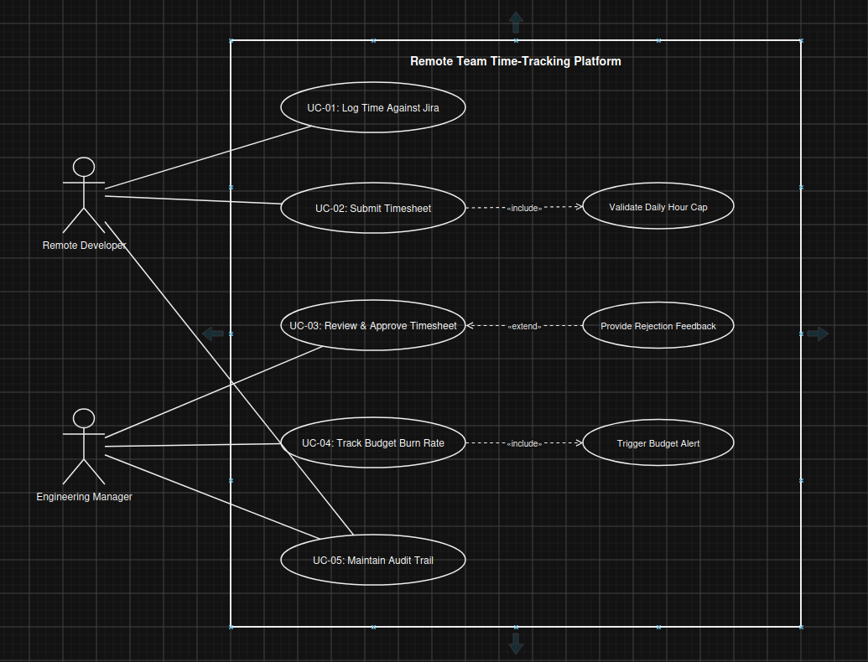
USE CASE SPECIFICATION: UC-03 Review & Approve Timesheet

ACTORS:

- Engineering Manager (Primary)
- Remote Developer (Secondary)
- Notification Engine (External System)
PRECONDITIONS:

- The Remote Developer has submitted their weekly timesheet.
- The timesheet status is currently in "Pending Approval".
POSTCONDITIONS:

- The timesheet state transitions to either "Approved" or "Rejected".
- Project budget dashboards recalculate based on approved hours.
- An immutable audit trail entry is created.
MAIN SUCCESS SCENARIO (Happy Path - Approval)

- The Engineering Manager navigates to the Timesheet Approvals dashboard.
- The Manager selects a pending weekly timesheet submitted by a Remote Developer.
- The system presents all logged hours mapped to corresponding Jira issue IDs, task descriptions, daily breakdowns, and cumulative project burn impact.
- The Manager clicks the "Approve" button.
- The system updates the timesheet status to "Approved" and locks all included time records against further modifications.
- The system recalculates total project budget consumption in real-time.
- The system writes an immutable audit record containing Manager ID, Developer ID, total approved hours, and the approval timestamp.
- The system displays a success confirmation message to the Manager and removes the timesheet from the pending queue.
ALTERNATE FLOWS

Alternate Flow A: Timesheet Rejection (Rejection with Feedback)
3a. The Manager reviews the line items and identifies incorrect billing allocations or excessive unverified hours.
4a. The Manager clicks the "Reject" button.
5a. The system prompts the Manager with a mandatory rejection comment modal.
6a. The Manager enters corrective feedback and confirms the rejection.
7a. The system sets the timesheet status to "Rejected", unlocks the records for developer edits, logs the rejection note in the audit trail, and sends an automated notification to the Developer.

Alternate Flow B: Budget Threshold Breach Triggered Upon Approval
6b. During financial recalculation, total project spending reaches or crosses the 80% or 100% threshold.
6b.1. The system completes the approval transition and immediately dispatches an automated high-priority alert notification to the Engineering Manager.

Exception Flow C: Empty Rejection Feedback Attempt
6c. The Manager attempts to submit a rejection without entering comments.
6c.1. The system blocks the operation, displays an inline validation error stating feedback is required, and keeps the timesheet in "Pending Approval" until valid feedback is provided.

